Report on Industrial Training

**A report of training undergone at**

**JEDUX PARENTERALS PVT. LTD.**

**Submitted in Partial Fulfillment of B. Pharm VIth Semester**

### Subject- Industrial Training

**(BP-610P)**

**by**

**PRINCE SRIVASTAVA**

**(2109190500043)**

**Session 2023-24**

**Dr. A. P. J. ABDUL KALAM TECHNICAL UNIVERSITY, LUCKNOW**

**(Formerly Uttar Pradesh Technical University, Lucknow)**

**Under the Supervision of**

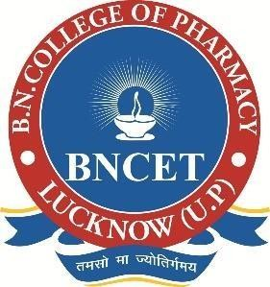**Prof. (Dr.) Ramesh Kumar Singh BNCP, Lucknow.**

**Mr. Virendra Kumar Singh BNCP, Lucknow.**

**to the**

**B. N. COLLEGE OF PHARMACY, LUCKNOW**

**(Affiliated to Dr. A.P.J Abdul Kalam Technical University, Lucknow)**

**MAY, 2024**

This is to certify that Mr./Ms. **PRINCE SRIVASTAVA** has been successfully completed Industrial Training (BP-610P) for the partial fulfillment of B. Pharm VIth semester, as per the syllabus of Dr. A. P. J. ABDUL KALAM TECHNICAL UNIVERSITY, LUCKNOW in the academic year 2023-24.

**Prof. (Dr.) Ramesh Kumar Singh Mr. Virendra Kumar Singh BNCP, Lucknow. BNCP, Lucknow.**

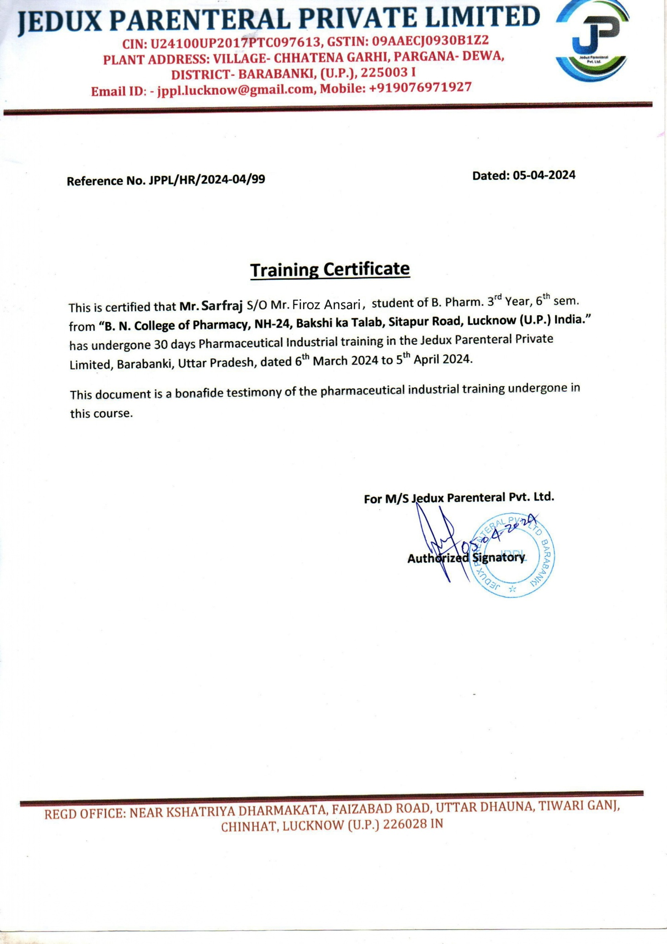

I hereby declare that the Industrial training carried out by me was undertaken in the certified industry **“JEDUX PARENTERALS PVT. LTD, LUCKNOW”** under the guidance of **“ASHUTOSH TIWARI (HR)**. Further, this work is not being submitted in part or in full to obtain any other degree/ diploma.

Place: Lucknow PRINCE SRIVASTAVA

Date: B.Pharm III Year

Roll No. - **2109190500043**

BNCP, Lucknow.

I would like to express my sincere gratitude to **JEDUX PARENTERALS PVT. LTD.** for providing me with the opportunity to undergo industrial training as a part of my academic curriculum. This experience has been invaluable in shaping my understanding of the practical applications of the knowledge gained during my academic studies.

I extend my heartfelt appreciation to [Supervisor/Manager's Name], my mentor during this training period, for their guidance, support, and encouragement. Their expertise and insights have been instrumental in enhancing my skills and competencies in [mention specific areas or tasks].

I would also like to thank all the staff members and colleagues at **JEDUX PARENTERALS PVT. LTD.** for their warm welcome and willingness to share their knowledge and experiences with me. Their cooperation and camaraderie have made my training experience enriching and memorable.

Furthermore, I am grateful to my academic institution for facilitating this training opportunity and for their continuous support throughout the process.

Last but not least, I am indebted to my family and friends for their unwavering support and encouragement, which has motivated me to make the most out of this training experience.

Thank you once again to everyone who has contributed to making this industrial training a rewarding and fulfilling journey.

Sincerely, PRINCE SRIVASTAVA

# TABLE OF CONTENTS

|  |  |  |
| --- | --- | --- |
| **Chapter**  **No.** | **Contents** | **Page No.** |
| **1** | **Introduction** | **1 - 2** |
|  | 1.1 Introduction of Industrial Training |  |
|  | 1.2 Objectives of Industrial Training |  |
| **2** | **Industry Profile** | **3 - 4** |
|  | 2.1 About Industry |  |
|  | 2.2 Mission |  |
|  | 2.3 Vision |  |
| **3** | **Product List** | **5** |
| **4** | **Departments In Industry** | **6 - 10** |
|  | 4.1 Raw Material Department |  |
|  | 4.2 Production Department |  |
|  | 4.3 Sterilization Department |  |
|  | 4.4 QA & QC Department |  |
| **5** | **Introduction to Parenteral** | **11 - 19** |
|  | 5.1 Guidance for Developing Formulations of Parenteral Drugs |  |
|  | 5.2 Parenteral Preparation Types |  |
|  | 5.3 Methods of Preparations |  |
|  | 5.4 Parenteral Manufacturing Layout |  |
| **6** | **Packaging** | **20 - 28** |
|  | 6.1 Primary Packaging |  |
|  | 6.2 Secondary Packaging |  |
| **7** | **Work Profile** | **29** |
| **8** | **Conclusion** | **30** |
| **9** | **References** | **31** |

## INTRODUCTION

### Industrial Training: -

There's a large gap in education between what students learn in the classroom and what employers really require. Industrial training closes this disparity. It incorporates both practical experience and book knowledge. Students receive instruction that prepares them for life after school in the workplace. Industrial training combines classroom instruction with on-the-job training.

As students look forward on their academic journeys, flipping through textbooks and struggling with theoretical frameworks, they often long for a real-world connection to the industries they hope to join. Industrial training becomes their bridge to that world, offering an easy chance into the desired heart of their chosen field. It's more than just a learning experience; it's a journey that takes them beyond the area of classrooms and textbooks.

Unlike sitting passively in lectures, industrial training demands active participation. It urges students to dive deep into the everyday challenges of the industry. Whether it's working in labs buzzing with experiments or on factory floors filled with the number of machineries, students get to see firsthand how things really work.

But it's not just about observation; it's about getting involved. In the world of industry, seasoned professionals step up to mentor eager students. It's a give-and-take relationship where knowledge flows both ways—the experienced learn from the fresh perspectives of the newcomers, while the novices soak in the wisdom of those who've been there before.

Moreover, through hands-on industrial training, students immerse themselves in real-world scenarios, encountering challenges that demand creative solutions. This process not only fortifies their technical expertise but also nurtures resilience and adaptability. As they navigate complex problems, they learn to collaborate effectively, harnessing the power of teamwork to achieve shared goals. Ultimately, industrial training empowers students to embrace uncertainty with confidence, equipping them to thrive in dynamic professional environments and drive innovation forward.

### Objectives of Industrial Training:-

1. **Practical Application:** To enable students to apply theoretical knowledge gained in academic settings to real-world situations within their chosen industry.
2. **Skill Development:** To provide opportunities for students to develop specific technical skills relevant to their field of study or industry, such as laboratory techniques, software proficiency, or manufacturing processes.
3. **Professional Exposure:** To expose students to professional work environments, allowing them to gain insight into workplace dynamics, culture, and expectations.
4. **Hands-on Experience:** To offer students hands-on experience in their field, allowing them to practice and refine their skills under the guidance of experienced professionals.
5. **Problem-Solving:** To enhance students' problem-solving abilities by presenting them with real-world challenges and tasks that require innovative solutions.
6. **Critical Thinking:** To foster critical thinking skills by encouraging students to analyze complex situations, evaluate options, and make informed decisions.
7. **Teamwork:** To promote teamwork and collaboration among students by engaging them in group projects and activities that require cooperation and communication.
8. **Time Management:** To help students develop effective time management skills by setting deadlines, managing priorities, and balancing multiple tasks simultaneously.
9. **Communication Skills:** To improve students' communication skills, both verbal and written, by engaging in interactions with colleagues, supervisors, and clients.
10. **Adaptability:** To cultivate adaptability and flexibility by exposing students to diverse work environments, challenges, and responsibilities.
11. **Professional Ethics:** To instill a sense of professional ethics and responsibility by emphasizing the importance of integrity, honesty, and respect in the workplace.

## INDUSTRY PROFILE

### About Industry:-



Fig no. 1: - Jedux Parenterals Pvt. Ltd. Building

Jedux Parenteral Pvt. Ltd. (JPPL) is recognized among the leading name in the field of manufacturing of sterile parenteral preparation (I.V. Fluids) This Plant is W.H.O. GMP certified and equipped with Form, Fill & Seal machineries and Glass Bottles Machinery for LVP the containers are formed, filled and sealed in closed circuit under most aseptic condition, which is totally devoid of any human touch. The aseptically sealed bottles are further sterilized in sophisticated superheated sterilizer at recommended temperature.

M/S Jedux Parenteral Private Limited is a private limited company registered for securing the certificate of incorporation from 06th October 2017 through the hands of Registrar of Companies, Kanpur, Uttar Pradesh. Registered office of the company is situated at Near Kshatriya Dharm Kata, Faizabad Road, Uttar Dhauna, Tiwariganj, District - Lucknow (U.P)- 226028.

#### Company Overview: -

* + - **Name**: Jedux Parenterals Private Limited
    - **Certifications**: W.H.O. G.M.P & ISO 9001:2015 Certified Company
    - **Incorporation Date**: October 6, 2017
    - **Registered Office**: Near Kshatriya Dharm Kata, Faizabad Road, Uttar Dhauna, Tiwariganj, District - Lucknow, Uttar Pradesh, India (Pin: 226028)

**Management**: -

* + - Mr. Jitendra Singh
    - Mr. Pradeep Kumar Singh
    - Mr. Bhanu Pratap Singh
    - Smt. Purnima Singh
  1. **Mission:-**
* Jedux Parenteral aims to create inspiring technology-driven products that enhance the application of medications for improved therapeutic purposes.
* Their core focus lies in providing sterile parenteral preparations, specifically I.V. fluids, to meet healthcare needs.
  1. **Vision** :-

It work on the motive of SERVICE BEFORE SELF and QULITY BEFORE QUANTITY .So that it can be renowned for the reliable and quality conscious manufacturing products at the most affordable prices to the benefit and complete satisfaction of the customers.

#### Contact Information

* + - **Factory Location**:

o Khasra No.-569,570,571,572

* + - * Village: Chhatena Garhi
      * Post: Moradabad, Pargana Dewa
      * Tehsil: Nawabgang, Barabanki, Uttar Pradesh (Pin: 225301)

## PRODUCT LIST

#### Dextrose Injection IP:

* + Available in 5% w/v and 10% w/v concentrations.

#### Sodium Chloride & Dextrose:

* + A combination of sodium chloride and dextrose.

#### Sodium Chloride Injection IP (0.9% w/v):

* + Also known as Ringer’s Injection.

#### Compound Sodium Lactate Injection IP (Ringer Lactate Solution for Injection IP):

* + A solution containing multiple electrolytes.

#### Levofloxacin Infusion IP:

* + An antibiotic infusion.

#### Multi Electrolyte Injection IP:

* + Formulated with essential electrolytes.

#### Sodium Chloride & Dextrose Injection IP (0.45% & 5% w/v):

* + A combination of sodium chloride and dextrose in varying concentrations.

#### Sodium Chloride Hypertonic Injection IP (1.6% w/v):

* + Used for specific medical purposes.

#### Mannitol Injection IP (20% w/v):

* + Mannitol solution for medical applications.

#### Paracetamol Injection IP (1% w/v):

* + Contains paracetamol for pain relief.

#### Ciprofloxacin Injection IP:

* + An antibiotic injection.

#### Metronidazole Injection IP:

* + Used for various infections.

#### Glycine Irrigation Solution IP (1.5% w/v):

* + Used for irrigation purposes.

#### Sodium Chloride Irrigation Solution IP (0.9% w/v):

* + Another solution for irrigation needs.

## DEPARTMENTS IN INDUSTRY

The Departments in the industry are:-

1. Raw Material Department
2. Production Department
3. Sterilization Department
4. Quality Control (QC)
5. Quality Assurance (QA)
6. Packaging
7. Labelling Department
8. Storage Area



Raw

Material

Storage

Production

Labelling

Departments

in Industry

Sterilization

Packaging

Quality

Control

Quality

Assurance

Fig no. 2: - Departments in Industry

## RAW MATERIAL DEPARTMENT

* The Department of Raw Materials plays a crucial role in guaranteeing the safety, integrity, and quality of pharmaceutical products, acting as the industry's backbone. This department is in charge of finding, acquiring, and managing raw materials. It works under strict quality standards and regulatory constraints.
* The department works to maintain a consistent supply of high-quality materials while minimizing risks and guaranteeing compliance with Good Manufacturing Practices (GMP) and other regulatory requirements through careful quality control checks, inventory management, and supplier relations.
* Its commitment to providing pharmaceutical products of the highest standard is shown by ongoing improvement projects, departmental collaboration, and a focus on safety. Essentially, the Raw Material Department plays a crucial role in maintaining the effectiveness and caliber of parenteral preparations.

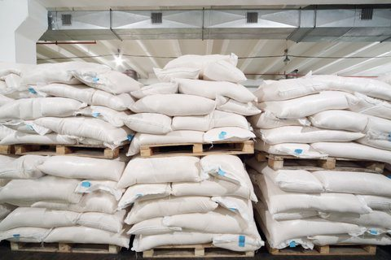

Fig no. 3: - Raw Material Department

## PRODUCTION DEPARTMENT

* The Production Department stands at the forefront of the Parenteral Preparation Industry, embodying a commitment to excellence in manufacturing pharmaceutical products.
* Its core mission revolves around the efficient, precise, and safe production of parenteral preparations, ensuring they meet exacting quality standards and regulatory requirements.
* Streamlined production processes ensure timely manufacturing of parenteral preparations while minimizing resource wastage and downtime.
* Strict adherence to quality control measures at every production stage maintains product integrity and regulatory compliance, meeting standards like Good Manufacturing Practices (GMP).
* Resource management practices are optimized to minimize waste and environmental impact while meeting production targets effectively.
* Flexibility and adaptability enable the department to respond to market demands, regulatory changes, and technological advancements swiftly.

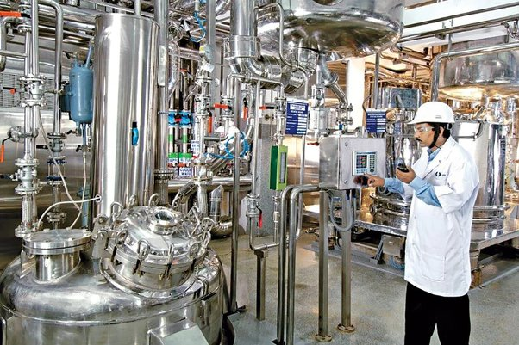

Fig no. 4: -Production Department

## STERILIZATION DEPARTMENT

In order to guarantee the effectiveness and safety of pharmaceuticals, equipment, and medical devices used in healthcare settings, the Sterilization Department is essential. This department protects against the existence of dangerous bacteria that could endanger patient health by carefully using sterilizing processes.

Sterilization is the process of completely eliminating or destroying all forms of microbial life, including bacteria, viruses, fungi, and spores, from surfaces, instruments, equipment, or substances. This ensures that the sterilized items are free from infectious agents and safe for use in medical procedures or pharmaceutical manufacturing.

* Sterilization utilizes diverse methods such as autoclaving, ethylene oxide sterilization, gamma irradiation, and hydrogen peroxide vapor sterilization.
* Precise packaging techniques post-sterilization are vital to maintaining sterility and preventing recontamination.
* Continuous monitoring and documentation of sterilization processes uphold quality and regulatory compliance.
* 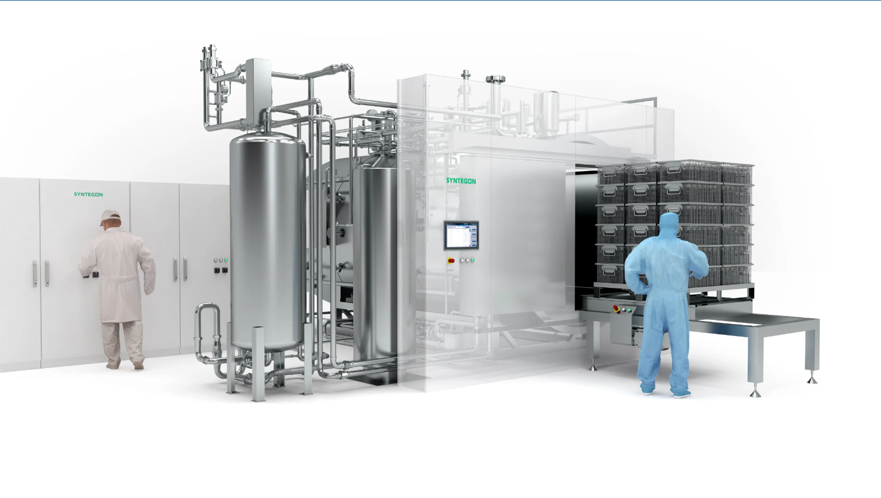Adherence to safety protocols and training of personnel minimize risks associated with sterilization procedures.

Fig no. 5: - Sterilization Department

## QA & QC DEPARTMENT

Within a business, the Quality Assurance (QA) and Quality Control (QC) departments are essential to guaranteeing the quality of the products, regulatory compliance, and customer satisfaction. Throughout the course of the product lifecycle, this department is in charge of putting quality management systems into place and keeping them up to date.

#### Key Responsibilities:

1. **Quality Assurance (QA):**
   * QA people make sure all the steps in making the medicine are done right. They set up rules and guidelines for how things should be done.
   * They check regularly to make sure everyone is following the rules and doing their jobs properly.

#### Quality Control (QC):

* + QC folks check the medicine at different stages to make sure it’s okay. They test the ingredients, check how the medicine is made, and make sure the final product is safe.
  + They use special tools and tests to check if the medicine is good to go. If something’s not right, they look into why and try to fix it.

#### Working Together and Improving:

* The QA & QC teams work closely with other teams like the people who come up with new medicines and those who actually make them.
* They are always looking for ways to make things better and safer. They use ideas like doing things more efficiently and learning from mistakes to keep improving.

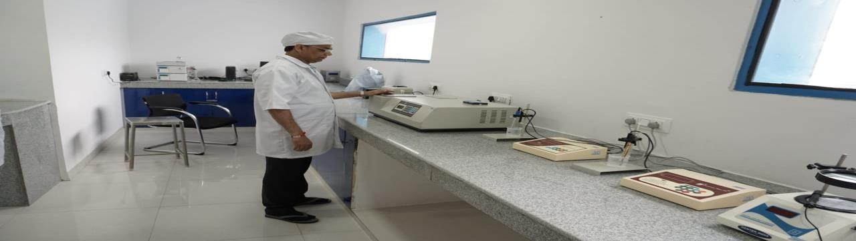

Fig no. 6: - QA & QC Department

## INTRODUCTION TO PARENTERALS

Parenterals are pharmacological formulations that are injected or infused into the body, usually via a route other than the digestive tract. These formulations provide fast and accurate drug administration by avoiding the gastrointestinal tract and entering the bloodstream or tissues directly. Parenteral preparations are frequently used to give drugs that have an immediate beginning of action, have low oral bioavailability, or are not appropriate for oral administration. They include injectable solutions, suspensions, emulsions, and powders for reconstitution.

Parenteral (Gk, para enteron, beside the intestine) dosage forms differ from all other drug dosage forms, because they are injected directly into body tissue through the primary protective systems of the human body, the skin, and mucous membranes. They must be exceptionally pure and free from physical, chemical, and biological contaminants. These requirements place a heavy responsibility on the pharmaceutical industry to practice current good manufacturing practices (cGMPs) in the manufacture of parenteral dosage forms and on pharmacists and other health care professionals to practice good aseptic practices (GAPs) in dispensing parenteral dosage forms for administration to patients.

**Formulation Principle of Parenteral: -**

Parenteral drugs are formulated as solutions, suspensions, emulsions, liposomes, microspheres, nano systems, and powders to be reconstituted as solutions. This section describes the components commonly used in parenteral formulations, focusing on solutions and freeze-dried products. General guidance is provided on appropriate selection of the finished sterile dosage form and initial approaches used to develop the optimal parenteral formulation.

**Unique Characteristics Of Parenteral Dosage Forms: -**

* All products must be sterile.
* All products must be free from pyrogenic (endotoxin) contamination.
* Injectable solutions must be free from visible particulate matter. This includes reconstituted sterile powders.
* All products must be stable.
* Products must be compatible, if applicable, with IV diluents and delivery systems.
  1. **GUIDANCE FOR DEVELOPING FORMULATIONS OF PARENTERAL DRUGS**

1. **Route of administration:**- Different routes require specific formulations (e.g., solutions, suspensions) due to considerations such as safety, tissue sensitivity, and administration method.
2. **Dosage form based on route:-** Intravenous routes require solutions or microemulsions; subcutaneous or intramuscular routes may use suspensions or microparticulate delivery systems.
3. **Pharmacokinetics:-** Drug absorption, distribution, metabolism, and excretion influence route and formulation choice. Rapid pharmacokinetics may require modified release formulations.
4. **Drug solubility:-** Insoluble drugs may need co-solvents or dispersed system formulations to maintain solubility.
5. **Drug stability:-** Stability issues may necessitate freeze-dried or solid dosage forms. Concentration affects stability and packaging choices.
6. **Compatibility:-** Formulation additives and packaging must be compatible with the drug to avoid degradation or adverse reactions.
7. **Silicone use:-** Silicone in packaging may induce protein aggregation, requiring compatibility studies. Alternative packaging materials can minimize compatibility issues.
8. **Packaging considerations:**- Packaging selection is influenced by marketing and competition, with formulation compatibility being a key factor.
9. **Manufacturing considerations:-** Formulations must be compatible with manufacturing processes such as sterilization, filling, and storage, ensuring product quality and stability.
10. **Patient compliance:-** Dosage form selection may consider factors like ease of administration, frequency of dosing, and patient preference to enhance adherence to treatment regimens.
11. **Allergic reactions and sensitivities:-** Formulation ingredients should be chosen carefully to minimize the risk of allergic reactions or sensitivities in patients, especially for parenteral products where direct exposure to the bloodstream occurs.

## PARENTERAL PREPARATION TYPES

1. **Solutions:-** One of the most popular kinds of parenteral preparations is a solution. One or more active pharmaceutical ingredients (APIs) are dissolved in an appropriate solvent or vehicle to create a homogenous mixture. Water for injection (WFI), saline solutions, and different organic solvents are often used solvents, depending on the drug's solubility properties. For medications that need to take effect quickly and are highly soluble, solutions are beneficial.
2. **Suspensions:-** Another crucial kind of parenteral preparation is suspensions. They are made up of solid particles scattered throughout a liquid medium. In contrast to solutions, the medication is suspended in the vehicle rather than dissolved. When a medicine's solubility is restricted or when a regulated release of the drug is required, suspensions are employed. For suspension formulations to avoid settling and guarantee constant dosage, particle size, homogeneity, and stability are essential components.
3. 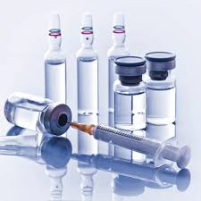**Emulsions:-** Colloidal dispersions of one immiscible liquid (the scattered phase) inside another liquid (the continuous phase) are called emulsions. Emulsions of water in oil (W/O) and oil in water (O/W) are typical examples. Drugs with low solubility in both the water and oil phases, as well as situations requiring targeted distribution or sustained release, are treated with emulsions. Emulsions can experience phase separation over time, hence stability is an important factor to take into account while formulating them.

Fig no. 7: -Parenteral Preparations IV

1. **Powders for Reconstitution:-** Powders for reconstitution are lyophilized or spray-dried formulations that are converted into a liquid dosage form upon reconstitution with a suitable solvent, typically sterile water or saline. These formulations offer advantages such as improved stability, reduced shipping costs, and ease of reconstitution at the point of care. They are commonly used for biologics, peptides, and certain antibiotics.
2. **Injectable Implants:-** Injectable implants consist of solid or semi-solid formulations intended for implantation into tissues, where they gradually release the drug over an extended period. These implants can be biodegradable or non-biodegradable and are used for sustained release of drugs, local therapy, or tissue regeneration. Implants offer the advantage of providing controlled and prolonged drug release while minimizing the need for frequent dosing.
3. **Liposomes:-** Liposomes are lipid-based vesicles used to encapsulate drugs for delivery to specific tissues or cells. They consist of phospholipid bilayers surrounding an aqueous core, allowing both hydrophilic and hydrophobic drugs to be encapsulated. Liposomes offer advantages such as improved drug solubility, targeted delivery, and reduced systemic toxicity. They are particularly useful for delivering drugs with poor aqueous solubility or drugs requiring intracellular delivery.



Fig no. 8: -Parenteral Preparation Types

## METHODS OF PREPARATIONS

The manufacturing process for parenteral products involves several critical steps to ensure safety, sterility, and efficacy. Followings are the steps in which the parenteral products are manufactured:

#### Formulation Development:

* + **Active Ingredient Selection**: Determine the primary drug component and understand its properties.
  + **Route of Administration**: Choose the appropriate route (e.g., intravenous, intramuscular, subcutaneous).
  + **Excipient Selection**: Identify suitable excipients (stabilizers, solvents, buffers) to enhance drug stability.
  + **Pharmacokinetics Assessment**: Study drug absorption, distribution, metabolism, and excretion.
  + **Safety Evaluation**: Assess potential side effects and adverse reactions.
  + **Solution vs. Lyophilized Form**: Decide whether the drug will be a solution or a freeze-dried (lyophilized) product.
  + **Vial and Stopper Selection**: Choose appropriate vials and stoppers.
  + **Filtration Techniques**: Define protocols for filtration during manufacturing.
  + **Labeling, Packaging, and Storage**: Establish guidelines for labeling and storage conditions.
  + **Microbial Control**: Ensure the product is free from microorganisms, pyrogens, and particulate matter.

#### Types of Injectable Drug Products:

* **Injectable Solution:** The drug is dissolved in water (or another solvent) with added excipients.
* **Injectable Suspension:** Drug crystals are wetted to prevent floating, and suspending agents prevent settling.
* **Injectable Emulsion:** The drug is dissolved in oil, which is then emulsified with water using an emulsifying agent.

1. **Manufacturing Steps:**
2. **Formulation Development:**

* Design the formulation considering factors like drug stability, solubility, and compatibility.
* Determine the route of administration and desired pharmacokinetic profile.
* Develop a formulation that meets regulatory requirements and patient needs.

1. **Sterilization of Components:**

* Sterilize all components (containers, closures, and the product) to prevent microbial contamination.
* Common sterilization methods include autoclaving, filtration, and gamma irradiation.
* Ensure that sterilization methods are validated and comply with regulatory standards.

1. **Aseptic Processing:**

* Conduct all operations in a controlled environment, such as a cleanroom, to maintain sterility.
* Use sterile equipment and materials throughout the manufacturing process.
* Follow strict procedures to prevent microbial contamination, including gowning and environmental monitoring.

1. **Component Preparation:**

* Prepare components (vials, syringes, stoppers) for filling.
* Wash, sterilize, and inspect components to ensure quality and compliance.
* Ensure that all components meet specified standards before use in manufacturing.

1. **Filling and Closing:**

* Fill the formulation into final containers using automated filling equipment.
* Maintain accuracy in filling volumes and minimize air bubbles to ensure product integrity.
* Seal containers with appropriate closures to prevent contamination and maintain sterility.

#### Visual Inspection:

* + Perform visual inspection of finished parenteral products to detect defects.
  + Inspect for particles, cracks, leaks, and other imperfections.
  + Utilize automated inspection systems for efficiency and accuracy.

#### Labeling and Packaging:

* + Label products with necessary information such as dosage, expiration date, and lot number.
  + Package products into final packaging, including secondary packaging for additional protection.
  + Ensure labeling and packaging comply with regulatory requirements.

#### Quality Control Testing:

* + Sample batches for extensive testing to ensure compliance with specifications.
  + Conduct assays for identity, purity, potency, and sterility.
  + Ensure compliance with Good Manufacturing Practices (GMP) and regulatory standards.

#### Batch Release:

* + Release batches for distribution and sale after successful completion of quality control tests.
  + Issue a release certificate confirming compliance with regulatory requirements.
  + Ensure proper documentation and record-keeping throughout the manufacturing process.

#### Continuous Improvement:

* + Implement measures for continuous process improvement.
  + Monitor manufacturing processes and address any deviations or non-conformances.
  + Stay updated with advancements in technology, regulations, and industry best practices.

## PARENTERALS MANUFACTURING LAYOUT

#### Sterile Processing Area/Cleanroom:

* + - * The sterile processing area, often referred to as a cleanroom, is a controlled environment with low levels of airborne particles and microbial contamination.
      * It includes facilities for personnel gowning and entry, as well as air filtration systems to maintain sterility.
      * Cleanrooms are classified according to the number of particles per cubic meter of air and are designed to meet regulatory standards such as ISO 14644.

#### Solution Preparation Area:

* + - * This area is dedicated to preparing the solutions, buffers, and media required for parenteral product formulation.
      * It includes equipment such as mixing tanks, filtration systems, and weighing stations.
      * Solutions are prepared under controlled conditions to ensure accuracy and sterility.

#### Sterilization Area:

* + - * The sterilization area houses equipment and facilities for sterilizing components such as vials, ampoules, stoppers, and closures.
      * Common sterilization methods include autoclaving, filtration, and gamma irradiation.
      * Validation of sterilization processes is essential to ensure the efficacy of sterilization.

#### Filling Area:

* + - * The filling area contains equipment for filling the formulated product into final containers such as vials, ampoules, syringes, and cartridges.
      * Automated filling machines are used to ensure accuracy and efficiency in filling volumes.

#### Closing and Sealing Area:

* + - * This area is dedicated to sealing the filled containers with appropriate closures to maintain product integrity.
      * Equipment such as crimping machines, capping machines, and sealing machines are used for closing and sealing operations.

#### Visual Inspection Area:

* + - * Filled and sealed containers undergo visual inspection to detect defects such as particles, cracks, or leaks.
      * Automated inspection systems are often used to enhance efficiency and accuracy in detecting defects.

#### Packaging Area:

* + - * The packaging area is where the finished products are labeled and packaged into their final packaging.
      * Equipment such as labeling machines, cartoners, and shrink-wrapping machines may be used for packaging operations.

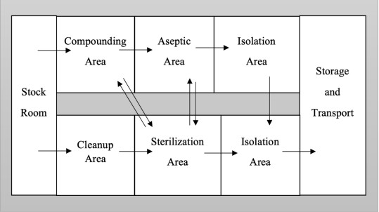

Fig no. 9: -Parenteral Manufacturing Layout

## PACKAGING

The pharmaceutical industry uses packaging for many purposes more than only protection and confinement. It is essential for preserving the integrity of the product, guaranteeing patient safety, meeting regulatory requirements, and enabling effective distribution. This chapter offers a thorough review of the materials, design considerations, and regulatory ramifications of the many packaging types used in pharmacies, including primary, secondary, and tertiary packaging.

#### Functions of Packaging:

Packaging serves multiple functions beyond mere containment. Here are some key functions:

* **Containment:** Packaging holds the product securely, preventing spillage, leakage, or breakage.
* **Protection:** It shields the product from external factors such as light, moisture, air, and physical damage during transportation, storage, and handling.
* **Preservation:** Packaging helps preserve the quality, freshness, and shelf life of the product by minimizing exposure to environmental elements and contaminants.
* **Information:** Packaging provides essential information to consumers, including product details, usage instructions, nutritional facts, safety warnings, and expiration dates.
* 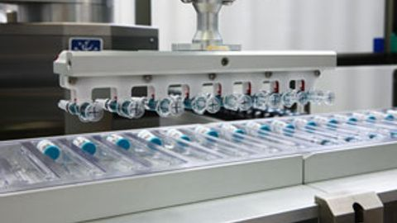**Convenience:** Packaging should be user-friendly, offering features like easy-open seals, resealable closures, and ergonomic designs for convenient storage and usage.

Fig no. 10: -Parenteral packaging

#### Types of Packaging:

Packaging comes in various forms, each tailored to specific products, industries, and consumer preferences. Some common types include:

1. **Primary Packaging:** The immediate enclosure of the product, coming into direct contact with its contents. Examples include bottles, jars, cans, blister packs, tubes, and sachets.
2. **Secondary Packaging:** Surrounds primary packaging, providing additional protection, information, and branding opportunities. Examples include cardboard boxes, shrink wrap, cartons, and display cases.
3. **Tertiary Packaging:** Outer packaging used for bulk transportation and storage of multiple units of primary or secondary packaging. Examples include pallets, stretch wrap, corrugated boxes, and shipping containers.

#### Materials Used in Packaging:

Packaging materials play a crucial role in ensuring product integrity, safety, and sustainability. Common materials include:

1. **Plastics:** Versatile, lightweight, and durable, plastics are widely used in packaging for their flexibility, barrier properties, and cost-effectiveness. Examples include PET, HDPE, LDPE, PP, and PVC.
2. **Glass:** Transparent, inert, and recyclable, glass is often used for packaging beverages, pharmaceuticals, and cosmetics, offering excellent barrier properties and product visibility.
3. **Paper and Cardboard:** Renewable, biodegradable, and easily customizable, paper and cardboard are popular choices for packaging boxes, cartons, and labels, offering strength, printability, and recyclability.
4. **Metals:** Aluminum and steel are used for packaging beverages, canned foods, and pharmaceuticals, providing excellent barrier properties, durability, and recyclability.

Packaging plays a pivotal role in the pharmaceutical industry, encompassing primary, secondary, and tertiary layers of protection, information, and branding. Understanding the functions, materials, design considerations, and regulatory implications of each packaging type is essential for ensuring product integrity, patient safety, and compliance with industry standards and regulations. By adopting innovative and sustainable packaging solutions, pharmaceutical companies can enhance product quality, consumer trust, and environmental responsibility in the global healthcare landscape.

### Primary Packaging:

Primary packaging represents the immediate enclosure of pharmaceutical products and comes into direct contact with the contents. It serves several essential functions:

* + - **Containment:** Primary packaging holds the medication securely, preventing contamination and maintaining dosage accuracy.
    - **Protection:** It shields the product from external factors such as light, moisture, and air, preserving its stability and efficacy.
    - **Information:** Primary packaging provides essential product information, including dosage instructions, expiration dates, and safety warnings.
    - **Child Resistance:** For certain medications, primary packaging incorporates child-resistant features to prevent accidental ingestion.
    - **Tamper Evidence:** Tamper-evident seals or packaging are employed to ensure the integrity of the product and detect any unauthorized access or tampering.

#### Common Types of Primary Packaging:

* + - **Bottles:** Glass or plastic bottles are widely used for liquids, suspensions, and oral medications.
    - **Blister Packs:** These pre-formed plastic cavities are sealed with foil or plastic film, providing individual doses of solid oral medications.
    - **Ampoules and Vials:** These small, single-dose containers are typically made of glass and sealed with a breakable top or aluminum cap.
    - **Prefilled Syringes:** Ready-to-use syringes are filled with liquid medications and sealed for sterile administration.
    - **Dropper Bottles:** These bottles come with a built-in dropper for precise dispensing of liquid medications.
    - **Tube Packaging:** Aluminum or plastic tubes are used for semi-solid medications like creams, ointments, and gels.

#### Materials for Primary Packaging:

* + - **Glass:** Offers excellent barrier properties and chemical resistance, ideal for sensitive medications.
    - **Plastic:** Lightweight, durable, and cost-effective, with various options such as HDPE, LDPE, PET, and PP.
    - **Aluminum:** Provides excellent protection against light, moisture, and oxygen, commonly used for blister packs and tube packaging.

#### Vials:

* + **Material:** Typically made of glass, which is inert and compatible with a wide range of medications.
  + **Closure:** Sealed with rubber stoppers and aluminum caps or crimp seals to maintain sterility.
  + **Uses:** Commonly used for storing liquid medications, as well as lyophilized (freeze-dried) products that require reconstitution before administration.
  + **Advantages:** Provides excellent barrier properties, compatibility with a variety of drugs, and ease of storage and transport.
  + **Considerations:** Glass vials can be fragile and may break if mishandled. Special care is needed during handling and storage to prevent damage.

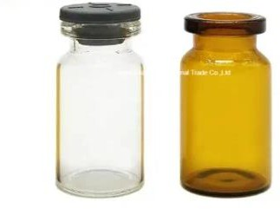

Fig no. 11: Vials

#### Ampoules:

* + **Material:** Made of glass, which provides a hermetic seal and protection from external contaminants.
  + **Closure:** Sealed by melting the glass neck after filling to ensure sterility.
  + **Uses:** Ideal for single-dose medications that require protection from light and air, such as certain vaccines, antibiotics, and analgesics.
  + **Advantages:** Offers excellent protection against contamination and tampering, as each ampoule is sealed individually.
  + 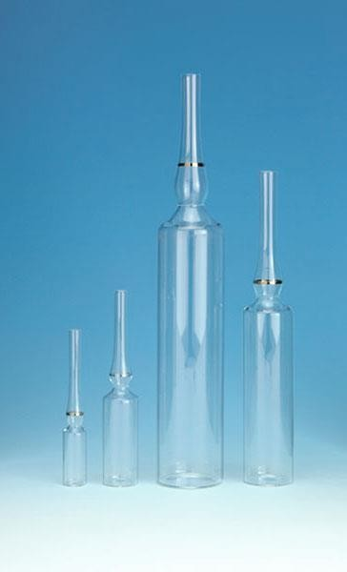**Considerations:** Once opened, ampoules cannot be resealed, making them unsuitable for multi-dose medications. Glass ampoules are also prone to breakage if mishandled.

Fig no. 12: Ampules

#### Prefilled Syringes:

* + **Material:** Available in both glass and plastic variants, with glass being more common for injectable medications.
  + **Closure:** May include attached needles or be designed for needle-free administration.
  + **Uses:** Convenient for single-dose administration of medications, including vaccines, biologics, and emergency drugs.
  + **Advantages:** Offers precise dosing, reduced risk of medication errors, and convenience for healthcare professionals and patients.
  + **Considerations:** Prefilled syringes can be more expensive than traditional vials or ampoules. Plastic prefilled syringes may have limitations in compatibility with certain medications.

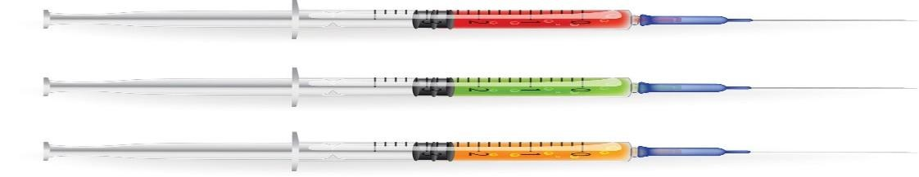

Fig no. 13: Filled syringe

**Cartridges:**

Cartridges serve as a versatile option for storing and administering liquid medications, especially in the context of auto-injectors and pen injectors. Here's a detailed breakdown of their features, applications, advantages, and considerations:

* **Features:** Material: Primarily made of glass or plastic, with glass being more prevalent for injectable medications. The choice of material depends on factors such as compatibility with the medication and manufacturing processes.
* **Closure:** Typically sealed with rubber stoppers and aluminum caps or crimp seals, similar to those used for vials. This sealing mechanism ensures the integrity of the medication during storage and transportation.
* **Applications:** Storage and Administration: Cartridges are utilized for storing and dispensing larger volumes of liquid medications. They are commonly employed in auto-injectors and pen injectors, which facilitate precise dosage delivery.
* **Convenience:** Cartridges offer convenience, especially for patients who need to self-administer medication. They provide a straightforward mechanism for measuring and dispensing the required dosage.

**Considerations:** Cartridges may have limitations in terms of compatibility with certain delivery devices and may require specialized equipment for filling and sealing.

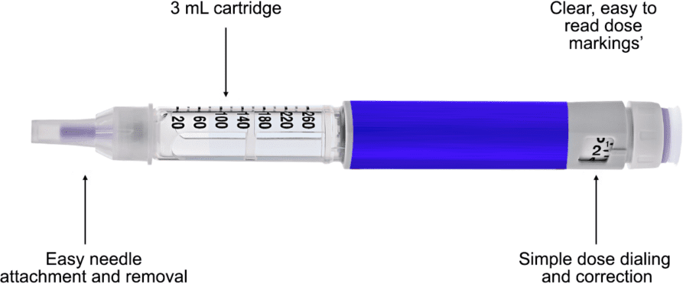

Fig no. 14: Cartridge

#### Infusion Bags:

* + **Material:** Made of flexible plastic materials such as polyvinyl chloride (PVC) or polyolefin.
  + **Closure:** Sealed with ports for attachment to infusion sets, typically using spike ports or luer connectors.
  + **Capacity**: Infusion bags come in various capacities, ranging from small volumes for pediatric use to larger volumes for adult patients or continuous infusion therapies.
  + **Uses:** Designed for storing and administering large volumes of liquid medications, including intravenous fluids, electrolytes, and parenteral nutrition solutions.
  + 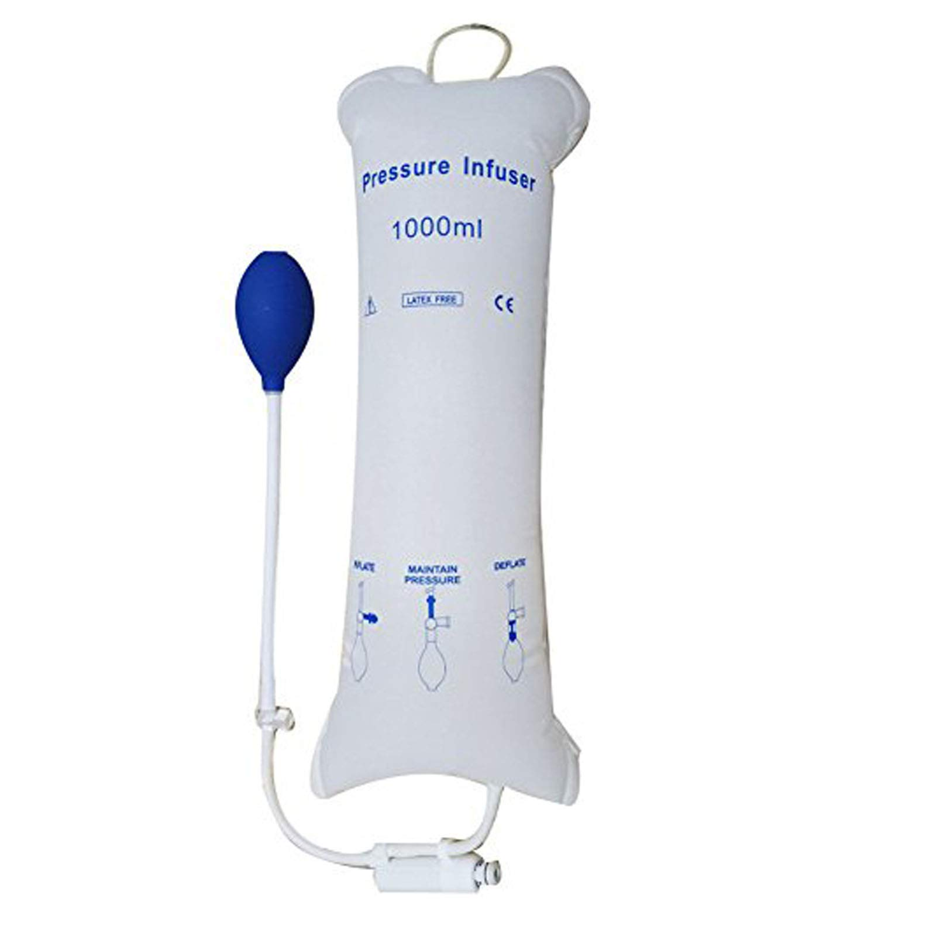**Advantages:** Provides flexibility in volume and administration rate, compatibility with infusion pumps, and reduced risk of air embolism.
  + **Flexibility:** The flexible nature of infusion bags allows for easy handling and manipulation during administration, making them suitable for various clinical settings.
  + **Considerations:** Plastic infusion bags may leach plasticizers or other additives into the medication, requiring consideration of compatibility and regulatory requirements.

Fig no. 15: Infusion Bags

### Secondary Packaging:

Secondary packaging surrounds primary packaging, providing additional protection, information, and branding opportunities. Its functions include:

* + - **Protection:** Secondary packaging safeguards primary packaging during transportation, handling, and storage.
    - **Identification:** It facilitates product identification, batch tracing, and inventory management.
    - **Promotion:** Secondary packaging serves as a marketing tool, showcasing branding elements, product features, and promotional messages.
    - **Information:** Additional product information, such as usage instructions, warnings, and patient leaflets, can be included in secondary packaging.

#### Common Types of Secondary Packaging:

* + - **Cartons:** Cardboard cartons are commonly used to contain multiple units of primary packaging, providing protection and branding opportunities.
    - **Shrink Wrap:** Heat-shrinkable plastic film is applied to bundle individual units or create multipacks, enhancing product visibility and tamper resistance.
    - **Display Boxes:** These cardboard boxes are designed for retail display, featuring product graphics and information to attract consumer attention.

#### Materials for Secondary Packaging:

* + - **Cardboard:** Provides strength, durability, and printability, ideal for cartons and display boxes.
    - **Plastic Film:** Shrink wrap films offer tamper resistance, protection, and product visibility.
    - **Paperboard:** Lightweight and recyclable, suitable for secondary packaging applications requiring less structural strength.

## WORK PROFILE

I was completely involved in all facets of Judex Pharmaceuticals Pvt. Ltd.'s operations during my internship, lending my passion and commitment to the pharmaceutical sector. Judex Pharmaceuticals Pvt. Ltd. specializes in the manufacturing of NS and RL bottles.

Along with supporting regulatory compliance initiatives, my duties also include documenting and preparing regulatory filings unique to the NS and RL bottle manufacturing industries. I am expanding my abilities and expertise in this particular field by learning about the complexities of pharmaceutical packaging through mentorship and practical experience. In addition to enabling me to put theoretical ideas into practice, this internship lays the groundwork for my future professional development in the pharmaceutical packaging sector.

Keep nurturing your passion and commitment, as they will undoubtedly drive your success in the pharmaceutical packaging sector. And remember, every experience, whether big or small, contributes to your professional journey.

* + - Engage in production support, quality control checks, and regulatory compliance tasks.
    - Assist in formulating and compounding pharmaceutical products following strict standard operating procedures.
    - Conduct thorough quality control checks on NS and RL bottles using analytical techniques.
    - Support regulatory compliance efforts, including documentation and preparation of regulatory submissions.
    - Gain hands-on experience and mentorship in pharmaceutical packaging from experienced professionals.

**Work Time:** 2 pm to 6 pm.

## CONCLUSION

To sum up, the industrial training experience has given me a great deal of insight into how to put the theoretical knowledge I've learned in school into practice. This program has facilitated both professional and personal growth in addition to improving technical abilities through practical experience and exposure to real-world situations. Working with seasoned professionals has given me a deeper awareness of industry standards, regulations, and practices.

Furthermore, in today's fast-paced workplace, the value of flexibility, teamwork, and ongoing education has been highlighted by this industrial training. The difficulties faced have provided chances for creativity and problem-solving, highlighting the importance of resilience and resilience in overcoming adversities.

In addition, the connections made with mentors and colleagues during this training session have prepared the groundwork for future networking and professional growth opportunities. The advice and assistance obtained have been crucial in helping to get a comprehensive grasp of the business environment and get ready for next projects.

All things considered, the industrial training program has been enlightening and life-changing, providing the confidence, skills, and information required to start a prosperous profession. I am appreciative of the chance and eager to use the knowledge I've gained to contribute significantly to the profession.

The transformative journey of your industrial training experience. It's evident how this program has not only bridged the gap between theory and practice but also fostered your professional and personal growth. The emphasis on adaptability, teamwork, and continuous learning resonates well with the demands of today's dynamic work environment. The challenges encountered have served as opportunities for innovation and resilience-building, further enhancing your skill set. Moreover, the invaluable connections forged with mentors and colleagues pave the way for future networking and career advancement. Overall, your reflection highlights the profound impact of the industrial training program in equipping you with the confidence, skills, and knowledge necessary for a successful career ahead.

## REFERENCES

1. Lieberman Lachman “The Theory and Practice of Industrial Pharmacy”, 4th edition, 2022, Published by CBS Publishers and Distributers , New Delhi
2. Remington “Essentials of Pharmaceutics” 1st edition, 2013, Published by Pharmaceutical Press, London
3. <https://slideplayer.com/slide/4463535/>
4. <https://jppl.org/Default.aspx>
5. https:/[/www](http://www.rpharms.com/).[rpharms.com/](http://www.rpharms.com/)
6. https:/[/www](http://www.pharm-int.com/2022/06/01/cartridge-pen-devices-make-self-injection-of-biologics-).[pharm-int.com/2022/06/01/cartridge-pen-devices-make-self-injection-of-biologics-](http://www.pharm-int.com/2022/06/01/cartridge-pen-devices-make-self-injection-of-biologics-) easy-and-safe/
7. https://jppl.org/gallery.aspx
8. https:/[/www](http://www.pharmtech.com/view/innovations-meet-growing-demand-for-prefilled-syringes).[pharmtech.com/view/innovations-meet-growing-demand-for-prefilled-syringes](http://www.pharmtech.com/view/innovations-meet-growing-demand-for-prefilled-syringes)
9. https:/[/www](http://www.slideshare.net/MArsaLanChisHti/parenteral-pres?from_search=0).[slideshare.net/MArsaLanChisHti/parenteral-pres?from_search=0](http://www.slideshare.net/MArsaLanChisHti/parenteral-pres?from_search=0)
10. https:/[/www](http://www.slideshare.net/slideshow/parenteral-preparations/63656591).[slideshare.net/slideshow/parenteral-preparations/63656591](http://www.slideshare.net/slideshow/parenteral-preparations/63656591)
11. https://en.wikipedia.org/wiki/Route_of_administration#Parenteral
12. https:/[/www](http://www.cincinnati.com/story/news/2018/01/15/no-iv-bags-cincy-hospitals-say-they-adapting-).[cincinnati.com/story/news/2018/01/15/no-iv-bags-cincy-hospitals-say-they-adapting-](http://www.cincinnati.com/story/news/2018/01/15/no-iv-bags-cincy-hospitals-say-they-adapting-) shortage-through-flu-season/1028683001/
13. https:/[/www](http://www.sks-science.com/ampule-vials-gold-band-prescored-clear-glass-ampules-p-5891.html).[sks-science.com/ampule-vials-gold-band-prescored-clear-glass-ampules-p-5891.html](http://www.sks-science.com/ampule-vials-gold-band-prescored-clear-glass-ampules-p-5891.html)
14. https://image.made-in-china.com/155f0j00ERjoDSvJhIzG/Tubular-Glass-Vial-with-Different- Color-Cap.webp